Julian Sas named his new album ‘Coming Home’. The gifted blues-rock guitarist explains: after many days on the road, after long hours in the studio, after exploring the unknown, home is always the place to return to. Where we find love and comfort. But, adds Julian, in a musical sense this record also feels like a ‘Coming Home’.

‘Coming Home’ is Julian Sas’s ninth studio album and the first as a foursome with new addition Roland Bakker on keyboards. Fans and critics paying attention to detail already noticed on Sas’s previous outing ‘Bound To Roll’, a modest change of direction. Especially the fat Hammond organ licks caught their attention. The Julian Sas Band is a band always on the move. Has always been searching for what makes the difference. Has always been pushing the boundaries of the genre. Sometimes faith offers a helping hand. Like when Julian Sas performed as one of the soloists at The Symphony In Blues Concert and met with the keyboard player of the orchestra: Roland Bakker. Musically they clicked right away and several jam sessions later it was obvious, guitar-virtuose Julian Sas had found his Blues Brother and a new sparring partner. The trio became a quartet.

Julian Sas: … it makes me feel real good to come up again with a new sound…a band on the move is always looking for new input, and new sounds… I’m very excited about my ‘new’ band with Roland Baker on keyboards and the strong, reliable rhythm section of Rob Heijne on drums and Fotis Anagnostou.on bass.
They are the best.

A song that highlights the new direction is the dark sounding ‘A Change Is Gonna Come’ in which Julian Sas on guitar and Roland Bakker on keyboard play a joint melody-line. The lyric, Julian explains, is about the quest of man. Where and why? Aren’t we all looking for a change? A life of freedom in every sense without fear? A life without threads of religious or political fanatics? Many of the songs on ‘Coming Home’ are about freedom, spiritual and physical, about taking responsibility and the like. In ‘Fear of Falling’ Julian expresses feelings about losing somebody very dear, the things unsaid, the last goodbye, the acceptance and at the same time the sad look full of fear…and the one staying behind knowing that once this will happen to him or her too. An emotional song somewhat reminiscent of Led Zeppelin. But there is also ‘Jump For Joy’ a BOOGIE in capital letters that captures the feel of joy and excitement when you walk on a stage to conquer a hungry audience… happiness, drive, passion, rock ‘n roll!

Julian Sas, by many considered to be Europe’s premiere master of the electric blues-guitar, recorded his first album in 1996 and called it “ Where Will It End!?” A question he is still unable to answer. Never? Julian Sas is a driven musician. Music is his passion. It’s his life. It never stops. Initially a hard-rocker fan, 13 years old Julian experienced a life changing moment when, for the first time, he heard a Muddy Waters record. That very day Julian decided to dedicate his life to blues and blues-rock. Four years later a 17-year-young Julian Sas attended a Rory Gallagher concert, that made an even more lasting impression. He decided to become a professional musician, has been on the road ever since and fronts one of the best and most popular live acts on the European club scene. This album might be called ‘Coming Home’ but that’s a state of mind. The road goes on forever. So where will it end? Nobody knows!

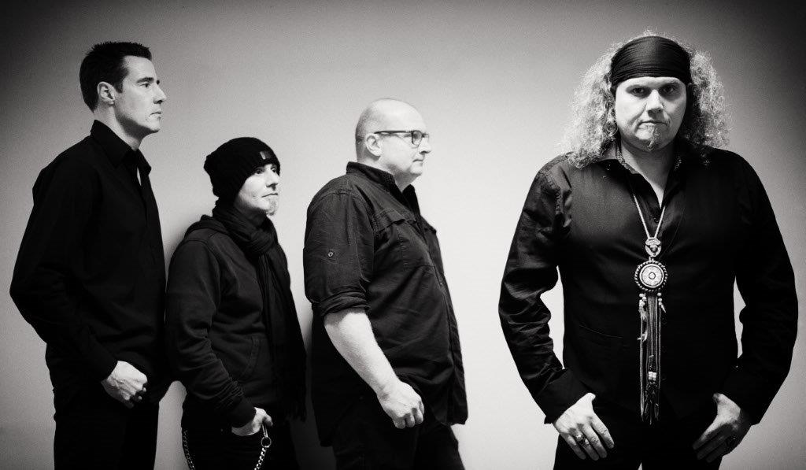
January 2016
Julian Sas Vocals & guitars
Roland Bakker Hammond organ and piano
Fotis Anagnostou. Bass
Rob Heijne Drums

